Warning Urgent From The God Who Loves You
6.22.26

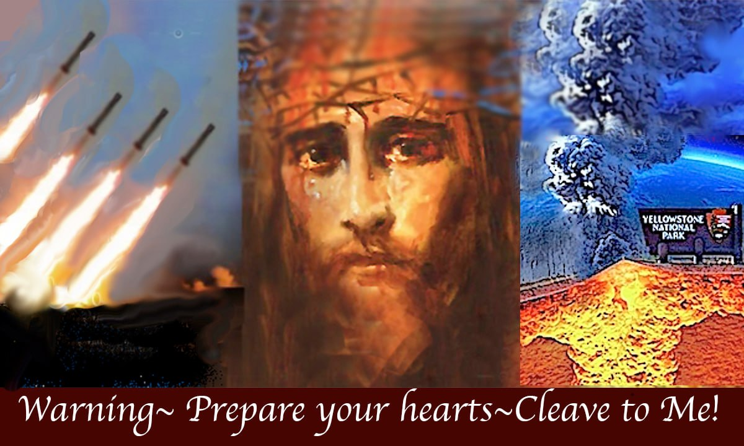

God bless you, my precious family.

It's so good to be together with you and to be able to share these messages. The Lord has come to me in an urgent way, asking that I would warn everyone of what is to come, so I'm going to get right into it.

The title of this message is an urgent warning from the God who loves you.

The Lord began,

Get ready for what is coming. Many are not ready. My beloved people, the end times have begun.
What you are living in is tame. What is coming is chaotic. Unless you are grounded in a one-on-one relationship with Me, you and your loved ones may not survive spiritually or physically. Come to Me and let's get it right before it's too late.

He continued,

Chaos is coming. Please prepare your hearts. Signs in heaven and earth are here now, even as it's written in Matthew 24. Wars and rumors of war, earthquakes, volcanoes, meteors, tsunamis, flooding, a worldwide surge
in great earthquakes nearly tripled over the last decade.

According to the Geological Society of America, and this is a quote from NBC, an earthquake increase of 265% has happened in the last 10 years. So don't let anyone tell you that there have always been earthquakes.

Yes, there have been earthquakes, but not like this, not the way they're multiplying now. And this is one of the signs the Lord warned us about.

And Jesus began to speak to me,

I have allowed signs to increase so you can prepare, not with stored up food, but with a clean heart and a sin-free life. This is no time to compromise. This is no time to indulge your flesh or to lie, steal, or sleep around.

Judgment is at the door.

I will protect the righteous. Even if their bodies fail, they will be with me in heaven. However, those who have chosen to live in sin will lose all hope, not because I'll take it from them, but because I am their only hope.
Truly, I care for you. Come to me and repent. I will bless you and hold you in my arms. You will have no fear.
You will be safe, and for the first time in your life, you will know real love. Trust in my goodness because I care for you. I love every one of you with a love you cannot imagine, and I will make myself known to you. Just ask.
I will wrap your heart in my love. Then you will know how much you mean to me. I am not a faraway God. I am always with you.

And I'd like to add here that the night that I was saved, when fire came down from heaven and engulfed my body, I felt love that I have never felt in my life. It was incredible. The sweetness of God just, it just slayed me.
It slayed me. It was so intensely sweet. I couldn't even stand, and it lasted for 40 minutes. Amazing. So truly amazing.

That's the kind of love that God has for us.

He continued,

I know when you sit, and I know when you stand, and I love you at all times. Yes, I do. I share in everything you feel. I bet that's something you didn't know. I share in everything you feel. I cry when you cry. I laugh when you laugh. And my world is full of joy when you're happy. I'm delighted in your presence. You truly mean everything to me. I proved that when I died on the cross and opened heaven for you. Please believe me. A life free from fear is waiting for you. I have arranged it on that day when you've had enough of Satan's propaganda, and you
long for truth, safety, and love. I will be waiting for you as your best friend.

And guys, that's the relationship he wants to have with you. He wants to be your best friend.

I will forgive, he continued.

I will forgive and even forget the plotting of ruin you did against my loyal servants. Yes, all the pain I will forgive. And you will be born again with a clean conscience and given the gift of new life from me. A life without fear. Please do not believe the enemy who constantly whispers lies and false narratives in your ears so he can cause you to panic and control you with fear. Come to me instead because I am waiting for you.

And in my presence, you will find peace and angelic protection from your enemies.

Now here, I just want to tell you a beautiful song that Father God gave to me. It's called Come to Me, and the link is below. And that is a beautiful song that he gave me to call me closer to him. I didn't have a father, so I didn't know what a father was, but he became my father after this song. And I had a wonderful dream about him. He and I were walking down the beach together and talking. So that's a song that you can look up on the internet. He was standing. God the Father was standing at a distance and beckoning me to come into his arm.
I did, and he held me tenderly.

To those who come to him, he is a tender father. Oh, please trust him. Ask any of my faithful servants, Jesus continued, and they will tell you the joys of working for me. They are never afraid or confused for long, never alone, never unloved, never abandoned, or without real on-time comfort when desperately needed.

You can listen to our testimony on YouTube, heart underscore dwellers, and check the videos out and also the book Chronicles of the Bride, and that's a written documentation of what happened the first time we went to heaven with the Lord. And it's in the book section, it's a free download, and the same for the song that's
in the music page, and he's referring to our book Chronicles of the Bride.

By the way, everything is a free download on the Heart Dwellers site, which you can find at heartdwellers.org on the internet. Prophetic Daily Messages from Jesus, heartdwellers.org. We are a community of prophetic believers sent to warn Christians and non-believers alike to be ready. Events are coming that Jesus wants to protect you from because He truly loves and cares for you, no matter how you feel about Him.

What is coming many will not survive because they are not spiritually equipped. Blessed are those who have ears to hear and hearts to obey. Blessed are they who love Me with their whole hearts and have rejected what the world will offer them. They, their loved ones and children, will be spared. If you have chosen to turn away from Me, I will wait patiently for you as long as you are still alive. Turn back and I will forgive and save you.

My love for you has never been compromised, never. No matter what you've done, I can still forgive you. Love is My standard, not anger, hatred, and retaliation, which is Satan's standard. Cross him and you die. Cross Me, repent, and I will embrace and forgive you and restore you. The world as you've known it is passing away, but in that hour, I will save those who call on Me.

And I will share with you this very short prayer that the Lord has asked us to say. This came through Father Ezekiel in his time with the Lord. This is called the Mother of Mercy Chaplet and it's set on a regular rosary.

Very simply,

merciful Father, please grant us more time, more grace, more mercy. Our Mother of Mercy, pray for us.
And you say that ten times on a rosary, a decade, and there's five decades altogether on the rosary.
In your heart is with the Holy Spirit.

He may show you scenes, things from the Congo or Sudan or any place in the world, Russia. Wherever people are crying out to God for mercy, this prayer applies. So please, dearly loved ones, pray for the world. Pray for the wars and the earthquakes and everything that's going on, but mostly please get right with God, make Him your best friend, spend time with Him, let Him speak to you.

Pray and He will answer you.

He's faithful.

